Name: Class:

Task 1
The following shows a database table named Customers. This is used in an activity centre. All activities need to cost less that £100 and activities must be 2 hours or less.
Table name: Activities
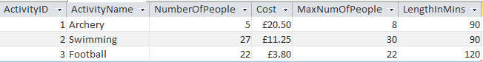
(a) Match each of the fields below with the validation rule that would be most appropriate.
Field |  | Validation rule
ActivityName |  | <100.00
NumberOfPeople |  | [NumberOfPeople]<=[MaxNumOfPeople]
Cost |  | <=120
MaxNumOfPeople |  | Length is 255 characters or fewer
LengthInMins |  | <30
(b) ActivityID is the primary key for the table.
Explain what the term primary key means.

Task 2
Two tables, tblEvent and tblPupil, are shown below.
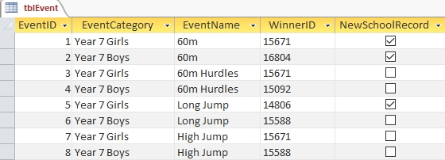
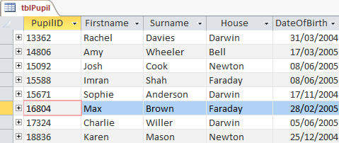
1. Write SQL statements to:
(a) select the “Firstname”, “Surname” and “DateOfBirth” columns from tblPupil.

(b) select the “EventCategory” and “EventName” columns from tblEvent for which new school records were set.

(c) select all columns from tblPupil for pupils in Darwin, Faraday or Bell.

(d) select all columns from tblEvent for which for which the Event category is Year 7 girls and the event name is either 60m or 60m Hurdles.

2. List the data that could be displayed after executing the following SQL queries on the database.
(a) SELECT FirstName, Surname, House
FROM tblPupil
WHERE House = 'Darwin'

(b) SELECT EventCategory, EventName
FROM tblEvent
WHERE EventName = 'Long Jump' OR EventName = 'High Jump'
Task 3
(a) Write an SQL statement to sort tblEvents in Task 2 into ascending order by EventCategory, displaying only the fields EventCategory, EventName and WinnerID.

(b) Write an SQL statement to sort tblPupil in Task 2 into descending order by Surname, displaying only the fields Firstname and Surname

Task 4
The following table, named Passengers, shows the data for passengers who have checked in for a flight.
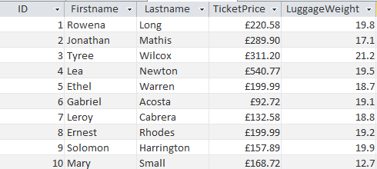
(a) Write an SQL statement to show the total value of all tickets for the flight.

(b) Write an SQL statement to show the total check in luggage weight.

(c) Write an SQL statement to count the number of passengers on the flight.

